Massaro Community Farm
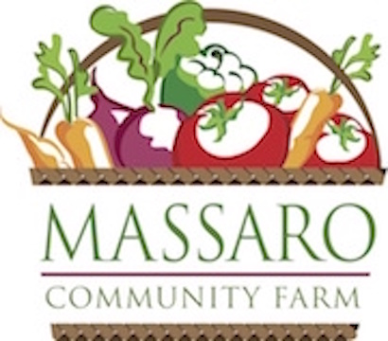

CSA: Community Supported Agriculture
2022 Registration Form
The mission of Massaro Community Farm is: keep farming, feed people, build community. Your subscription to our CSA provides you and your family a great variety of fresh, quality, Certified Organic produce throughout the season, and helps us realize our mission. CSA subscribers are invited to participate in on-farm and virtual events – enjoying the quality of life that a farm brings to our community.

Name(s): ______________________________ Email(s): ______________________________

Address:______________________________ Phone(s):_______________________________

Select Pickup Day – On Farm: Tuesday or Friday New Haven: Wednesday
Tuesday and Friday pickup times at the farm are 2:30pm-6:30pm.
Wednesday pickup times at District Athletic Club, 470 James St., are 3:30pm-7:30pm.

Sliding scale pricing engages the community in Community Supported Agriculture, allowing us to practice economic solidarity, providing mutual support for the cost of our programs. In this way we make our produce more accessible and help cover costs of operation. Choose the pricing tier that fits with your income and access to wealth, and help us create a more just, equitable food system.
All produce grown at Massaro Community Farm is Certified Organic.
2022 CSA Sliding Scale Pricing Tiers | Amount Paid
Market Price Summer CSA: Our current standard price; seeking to balance community affordability and farm viability.  20-week CSA: $695 ($34.75/wk); add $50 for delivery to New Haven  10-week flexible/half CSA: $375 ($37.50/wk); add $25 for New Haven  Supporter Price Summer CSA: 15% above our standard price; help create a more just, equitable food system by helping us cover the true costs of growing food and increase compensation for our farmers.  20-week CSA: $795 ($39.75/wk); add $50 for New Haven  10-week flexible/half CSA: $375 ($37.50/wk); add $25 for delivery to New Haven  Contributor price Summer CSA: ~35% above our standard price; covers the full difference between the solidarity and market prices, and shows your commitment to creating food equity in our community.  20-week CSA: $950 ($47.50/wk); add $50 for delivery to New Haven  10-week flexible/half CSA: $475 ($47.50/wk), add $25 for delivery to New Haven  Solidarity price Summer CSA: ~35% off our standard price; for those with lesser income or access to wealth. Limited availability.  20-week CSA: $440 ($22/wk)  10-week flexible/half CSA: $240 ($24/wk)  Massaro Organic Egg add-on: get 1 dozen eggs each week with your produce.  20-week Eggs: $120  10-week Eggs: $70 | Massaro Farm Pickup  $100 Deposit  or full payment for:  Summer CSA  Egg add-on  Fruit Option  Other ______  Subtotal ___________  District, New Haven:  $100 Deposit  or full payment for:  Summer CSA  Egg add-on  Fruit Option  Other ______  Subtotal ___________

2022 CSA Sliding Scale Pricing Tiers (con’t) | Amount Paid
15-Week Fruit Option from High Hill Orchard in Meriden:
Farm pickup on Tuesdays or Fridays: $110
Pickup in New Haven on Wednesdays: $120

Note: Minimum $100 deposit required (non-refundable). Payment in full always appreciated when possible. Full balance due prior to May 1, 2022.

Payment plans possible, please inquire.

Additional Contribution to our CSA: If you are able, please consider making an additional contribution towards your CSA purchase or purchase a CSA subscription for a family in need. | $25 $50 $75  $100 $250 $500  Other ______
Please make check(s) payable to Massaro Community Farm and send completed form to:
41 Ford Rd, Woodbridge, CT 06525 ___________________________________________TOTAL:

Massaro Community Farm strives to deliver each CSA subscriber a generous supply of diverse, high quality produce each week. I understand farming is subject to seasonality and risk associated with the growing season. As a CSA subscriber, I accept the inherent risks associated with farming and the potential variations in yield that may result.

______________________________________________
Please sign and date here to complete registration

Visit www.massarofarm.org for more information about our farm, programs, events and CSA.
Massaro Community Farm, 41 Ford Road, Woodbridge, CT 06525
Email: csa@massarofarm.org; Phone: 203-736-8618

